SETTLEMENT AGREEMENT AND RELEASE

This Settlement Agreement and Release (the “Settlement Agreement”) is entered into by and between the National Federation of the Blind (“NFB”) and Heidi Viens (“Viens”), on the one hand (“Plaintiffs”), and Scribd, Inc., (“Scribd”), on the other hand.

Recitals

- On or about July 29, 2014, NFB and Viens filed a complaint (“Complaint”) in the United States District Court for the District of Vermont, in an action entitled National Federation of the Blind, on behalf of its members, and Heidi Viens v. Scribd, Inc., Case No. 2:14-CV-162, asserting claims for alleged violations of Title III of the Americans with Disabilities Act (42
U.S.C. § 12182) (the “Action”);

- Scribd disputes the allegations of the Complaint;

- On or about October 12, 2015, Plaintiffs and Scribd entered into a written document constituting a non-binding expression of the terms by which they intended to resolve the Action (the “Non-Binding Term Sheet”);

- Plaintiffs and Scribd (collectively the “Parties” and each of them a “Party”) desire to settle the disputes between them, as this Agreement sets forth below; and

- The intent of this Settlement Agreement is to ensure that blind persons who use screen access software shall have effective and equal access to all of the various benefits sighted persons have in regards to the Website and related native mobile applications for iOS and Android. This is to be achieved by modifying Scribd’s existing Website as set forth below (and the native mobile applications only as Sections 3(c) and 3(d)(ii) specify below) so that it is accessible to blind persons on both desktop and mobile devices. Nothing in this Settlement Agreement shall require Scribd to continue offering any existing functionality or feature on its Website except to the extent such feature or functionality is necessary to ensure the Website is fully accessible or to ensure that all key functionalities offered on Scribd’s native mobile applications for iOS and Android are available to screen access software users on the Website with substantially equivalent ease of use. Notwithstanding any other part of this Settlement Agreement, nothing in this Settlement Agreement or any part of it shall impose any responsibility on Scribd for accessibility barriers posed by particular hardware or operating system environments.

- In consideration of the mutual covenants, representations, warranties, and other terms and conditions contained herein, the sufficiency of which all the Parties acknowledge, and without admission of liability by any of the Parties, each of the Parties agrees as follows:

Terms

  - Incorporation of Recitals. The Recitals above are incorporated herein by reference.

Definitions

    - “Website” means the website with the domain scribd.com. However, with respect to accessibility and the requirements of this Settlement Agreement, the Parties acknowledge and agree that the Website may render elements on mobile and small touch-screen devices differently from the rendering on desktop and laptop screens. For example, Scribd may include hover boxes on desktop and laptop screens even though they may not exist or display on mobile devices. As another example, Scribd may rearrange or resize elements to accommodate differences in dimensions between desktop/laptop displays and mobile device displays.

    - “Same transactions” means tasks that a sighted or blind user may accomplish to set up, manage, or terminate a Scribd account. However, the Parties acknowledge and agree that multiple methods may exist to achieve the same result (for example, tabbing with a screen reader, touching a touch screen, moving a cursor with a mouse, typing on a physical versus virtual keyboard).

    - “Access all of the same information” means that a user shall have the ability to access all Scribd-created instructions in conformance with Web Content Accessibility Guidelines 2.0 Level AA with ARIA and HTML5 support as to the Website, as well as the Accessible Scribd Literary Content that Section 3 describes.

    - “Substantially equivalent ease of use” means conformance with Web Content Accessibility Guidelines 2.0 Level AA with ARIA and HTML5 support.

    - “Publisher” means a company whose business is to publish books and ebooks (for example, HarperCollins, Harlequin, Penguin Random House, Hachette Livre, MacMillan Publishers, Simon & Schuster), not including individual users or small organizations who upload self-published works.

Accessibility of Scribd Website.

    - Scribd shall, with the assistance of Simply Accessible Inc. or another agreed-on third party vendor, perform automated and manual testing of the Website as set forth in the Project Proposal by Simply Accessible dated August 25, 2015 (the “Simply Accessible Proposal”).

    - Using the “High SA Effort” project timeline in the Simply Accessible Proposal as a guide, Scribd shall offer to the public a single, responsive website for all users, including desktop and mobile users, at the domain scribd.com that conforms to Web Content Accessibility Guidelines 2.0 Level AA with ARIA and HTML5 support to improve usability (“Website”). Blind users shall be able to engage in all of the same transactions and access all of the same information with a substantially equivalent ease of use.

      - The completion date for what the Simply Accessible Proposal defines as Phase III shall be December 31, 2017 (the “Completion Date”). Scribd shall conduct automated and manual testing at the completion of each milestone of the project timeline to confirm that it has been successfully completed, and timely remedy any compliance issues and usability barriers encountered.

2

    - During the term of this Settlement Agreement, Scribd shall address the accessibility of its native mobile applications for iOS and Android by the following two methods:

      - If Scribd performs a full rearchitecture of the iOS or Android apps, including a full rearchitecture of the interface and reader in the app, then Scribd shall ensure that the fully rearchitected app is fully accessible to blind users, and

      - If Scribd releases an upgrade of its iOS or Android apps (i.e., that requires a download), then Scribd shall ensure that the elements of the apps upgraded, updated, or revised (but not any functionality other than what Scribd has upgraded, updated, or revised) shall thereafter comply with the BBC Mobile Accessibility Standards and Guidelines v1.0 or its then-applicable successor for blind users.

    - After the Completion Date, Scribd shall:

      - Advise screen access software users who are considering downloading a Scribd native mobile application to use the Website instead, and

      - Ensure that all key functionalities offered on the native mobile applications for iOS and Android are available to blind users of the Website on mobile devices with substantially equivalent ease of use. In the case of downloads, which require the use of a mobile device, Scribd will make these available through the native mobile application in a way that a blind user can access for the purpose of selecting and reading downloaded books offline.

Accessibility of Literary Content.

    - By December 31, 2017, Scribd shall reprocess all EPUB ebooks that it has received from publishers to ensure that they are accessible with screen access software according to the existing International Digital Publishing Forum standard (available at http://www.idpf.org/accessibility/guidelines/). However, Scribd’s responsibility with respect to graphical content within those ebooks is limited to reprocessing and presenting such ebooks in a manner that retains publisher-provided descriptive data.

    - After December 31, 2016, Scribd shall process all EPUB ebooks that it receives from publishers to ensure that they are accessible with screen access software according to the existing International Digital Publishing Forum standard (available at http://www.idpf.org/accessibility/guidelines/). However, Scribd’s responsibility with respect to graphical content within those ebooks is limited to presenting such ebooks in a manner that retains publisher-provided descriptive data.

    - After the Completion Date, if a paying subscriber using screen access software requests a PowerPoint, Excel, or PDF file on Scribd to be provided in a text readable format, Scribd shall, to the extent allowed by contract and other law, process the file to make that format accessible to that subscriber, provided that Scribd shall only undertake processing of such documents as long as the cost to Scribd of doing so for all subscribers cumulatively is less than
$12,000 per calendar year.

3

    - Scribd shall have no obligation to continue offering any existing title to subscribers. Scribd shall have no obligation to create a derivative work of any document or ebook.

    - With the exception of materials that Section 4(f) describes, by January 1, 2016, Scribd shall not accept from publishers nor permit the uploading of any untagged or image PDF files from publishers to the Scribd library. On the Website, Scribd shall make available a link to the existing International Digital Publishing Forum standard (available at http://www.idpf.org/accessibility/guidelines/).

    - Scribd shall process and present comic books, illustration-heavy books (for example, children’s picture books, cookbooks, atlases, illustrated technical or repair manuals), graphic novels, maps, and sheet music with existing descriptive data in a manner that permits that existing descriptive data to be accessed by a Scribd user.

    - Scribd shall maintain all of the titles in its library in a manner that preserves any and all metadata provided by the publisher that is discoverable and that indicates that the title is accessible to readers with impaired vision. However, Scribd shall have no obligation to continue offering any existing title to subscribers.

    - By the Completion Date, Scribd shall make audiobooks available through the Website or native mobile applications in a way that a blind user can access with a substantially equivalent ease of use.

Maintenance of the Scribd Website and Literary Content.

    - Scribd shall implement a policy that, after the Completion Date, no change to a portion of the Website shall be released for public view or use until the change has been subject to testing and has been determined to be accessible. Scribd shall also implement a set of procedures accompanying the policy that establishes and explains the pre-release testing protocol. Scribd shall provide a confidential copy of the policy and the procedures to the NFB.

    - Scribd shall identify those employee groups and manager positions responsible for determining the accessibility of changes to the Website and authorizing the release of changes for public view or use. Scribd shall provide a confidential list of these groups and positions to the NFB.

    - Scribd shall resolve accessibility bugs with respect to Website features under the same service level arrangement and priority (for example, speed, resources used to resolve) that is applied to equivalent bugs not specifically related to accessibility. Scribd shall provide a confidential copy of the service level arrangement and priority policy to the NFB.

    - Scribd shall perform testing after Completion Date as follows:

      - During each calendar year after the Completion Date, Scribd shall perform automated testing for any minor release, and manual and automated testing for any major release, and in any event no fewer than one (1) manual and two (2) automated tests of the Website to assess the continuing conformance with the Web Content Accessibility Guidelines

4

2.0 Level AA with ARIA and HTML5 support so that blind users can engage in all of the same transactions and access all of the same information with a substantially equivalent ease of use.

      - If a given deficiency blocks a user from accessing a functionality without a posted work-around, Scribd shall remedy that deficiency within 60 days of discovery and if it has failed to do so, shall promptly notify the NFB.

    - Scribd shall implement a course of training for designers, engineers, and management (regardless of whether they are employees or independent contractors) appropriate for their roles in the development and maintenance of the Website. Scribd shall provide a confidential copy of the training materials to the NFB.

    - Within ninety (90) days of the execution of this Settlement Agreement, Scribd shall designate an employee who shall report to the Senior Vice President of Engineering or Head of Products, as the Website Accessibility Coordinator for the Website, and provide the Website Accessibility Coordinator’s name and contact information to the NFB. The Website Accessibility Coordinator shall be knowledgeable of the requirements of the Web Content Accessibility Guidelines 2.0 Level AA with ARIA and HTML5 support to improve usability, and website accessibility generally.

    - Within ninety (90) days of the execution of this Settlement Agreement, Scribd shall adopt and implement a Web Accessibility Policy and provide the Website Accessibility Policy to the NFB. The Web Accessibility Policy will be distributed to all relevant personnel on an annual basis. The Web Accessibility Policy will also be included as a link on the Website such that the Policy is publicly available.

  - Cooperation Regarding Press Releases. NFB, Viens, and Scribd shall cooperate and coordinate with each other and agree, prior to publication, on an initial press release, and any subsequent press release regarding this Settlement Agreement and/or the relationship between the parties. Any press release after the initial press release shall require consent of all parties to this Settlement Agreement.

  - Dismissal. In exchange for the consideration provided by Scribd, the Plaintiffs shall dismiss with prejudice the Action and their pending claims against Scribd within five (5) business days after the execution of this Settlement Agreement subject to the Court retaining jurisdiction to enforce the Settlement Agreement for the term of the Settlement Agreement. The Parties shall retain their rights to specifically enforce this Settlement Agreement.

Release by NFB and Viens and Covenant Not to Sue.

    - Effective upon full execution of this Settlement Agreement, Plaintiffs, on behalf of themselves, their agents, officers, directors, representatives, employees, affiliates, predecessors, successors, and assigns and any persons or entities acting by, through, under, or in concert with each of them, release and forever discharge Scribd, each of its past or present agents, representatives, employees, officers, directors, shareholders, parent or subsidiary companies, affiliates, predecessors, attorneys, successors and assigns, partners, insurers, and any persons acting by, through, under, or in concert with each of them (collectively “the Scribd Released Parties”), of and from any and all actions, causes of action, in law or in equity, suits,

5

liabilities, claims, demands, losses, damages, costs, or expenses, known or unknown, suspected or unsuspected, arising from the accessibility of Scribd’s Website, apps, and reading service, against the Scribd Released Parties (the “Released Claims”); provided, that this Release does not release and discharge the Parties from their respective obligations under this Settlement Agreement, nor does it release and discharge any action, cause of action, in law or in equity, suit, liability, claim, demand, loss, damage, cost, or expense belonging to an individual NFB member so long as they are not acting by, through, under, or in concert with the NFB or Viens.

    - Plaintiffs further covenant, during the term of this Settlement Agreement, not to sue, or to aid, assist, encourage, participate, facilitate, or endorse, any claims, complaints, or accusations that Scribd is violating or has violated any federal, state, or local law regarding disability discrimination with respect to the accessibility of its Website or of its native mobile applications for iOS and Android to the blind and visually impaired. However, Plaintiffs retain their right to seek enforcement of this Settlement Agreement pursuant to the dispute resolution process that this Settlement Agreement sets forth.

    - Waiver of Unknown, Unanticipated, and Unsuspected Claims. Plaintiffs agree and acknowledge their understanding that this Settlement Agreement fully and finally releases and forever resolves the matters released and discharged in this Section 8 of this Settlement Agreement, including those matters which may be or are unknown, unanticipated, or unsuspected.

      - Plaintiffs represent, certify, and acknowledge that they are each aware that they may hereafter discover facts in addition to or different from those which they each now know or believe to be true with respect to the subject matter of this Settlement Agreement, but that it is their intention hereby to fully, finally, and forever settle and release any and all disputes and differences that now exist, may exist, or have existed between the Parties, that are the subject of this Section 8, with the only exception being the Parties’ rights and obligations under this Settlement Agreement, together with its confidential rider (“Confidential Rider”) and the Simply Accessible Proposal. In furtherance of such intention, each of the Parties acknowledges that the general releases herein given shall be and shall remain in effect as full and complete general releases with respect to the matters released herein notwithstanding the discovery or existence of any additional or different facts.

      - The Parties, upon the advice of legal counsel, waive all benefits under California Civil Code Section 1542, as well as under any other statutes, laws of any of the states, and common law principles of similar effect. Plaintiffs acknowledge that they have read and understood California Civil Code Section 1542, which provides as follows:

A GENERAL RELEASE DOES NOT EXTEND TO CLAIMS WHICH THE CREDITOR DOES NOT KNOW OR SUSPECT TO EXIST IN HIS OR HER FAVOR AT THE TIME OF EXECUTING THE RELEASE, WHICH IF KNOWN BY HIM OR HER MUST HAVE MATERIALLY AFFECTED HIS OR HER SETTLEMENT WITH THE DEBTOR.

6

  - Attorneys’ Fees. The Parties agree that each Party shall pay or bear the expense of their respective attorneys’ fees through the execution of this Settlement Agreement as the Confidential Rider sets forth.

Dispute Resolution.

    - At any point during the term of the Settlement Agreement, but not more than once every sixty (60) days, if the NFB and Viens believe that Scribd is not in compliance with this Settlement Agreement, then the NFB and Viens shall notify Scribd in writing of the alleged noncompliance(s), specifically identifying same, and Scribd shall have sixty (60) days from receipt of such notice to cure the alleged breach(es). The NFB and Viens shall grant any reasonable request for an extension of this period upon Scribd’s written request.

    - If Scribd disputes the alleged breach, the parties shall attempt to resolve this dispute in a reasonable fashion, and shall, at the request of either, engage a mediator to assist. The parties shall equally divide the cost of the mediation. If the matter is not resolved by such attempts or if Scribd does not otherwise cure its alleged breach, the NFB may bring a motion to specifically enforce this Settlement Agreement and resolve the dispute with respect to the alleged breach, only. Fees and costs incurred in any such motion may be claimed and recovered by the prevailing party in accordance with applicable law. The National Federation of the Blind preserves its right to argue that fees and costs are recoverable under the standards in Christiansburg Garment Co. v. Equal Employment Opportunity Commission, 434 U.S. 412 (1978). Scribd preserves its right to argue that no fees are recoverable based on the dispute being covered solely by contract law. The United States District Court for the District of Vermont shall retain jurisdiction of this case for the Term of this Settlement Agreement.

  - Term of the Settlement Agreement. The term of this Settlement Agreement shall be until December 31, 2020 (the “Initial Term”).

    - After the Initial Term, the term of this Settlement Agreement shall renew for one year every year on December 31 unless: (i) either party informs the other in writing at least ten (10) business days prior to December 31 that the party declines to renew the Settlement Agreement term (in which event, this Settlement Agreement shall terminate on December 31 of that year), or (ii) Scribd becomes insolvent, or otherwise enters into liquidation, or has a receiver or trustee appointed to administer its property or affairs, in which case the Parties’ duties and rights shall be observed according to Section 12(l).

    - Termination of this Settlement Agreement pursuant to this Section 11: (a) shall only terminate the Parties’ respective rights and obligations under Sections 2, 3, 4, 5, and 10; and (b) shall not terminate or otherwise affect the other respective rights and obligations of the Parties under this Settlement Agreement.

Miscellaneous Terms.

    - Entire Agreement. This Settlement Agreement, together with the Confidential Rider and the Simply Accessible Proposal to the extent it is referred to in this Settlement Agreement, contain the entire agreement and understanding of the parties with respect to the matters set forth herein, and supersedes all other prior negotiations, agreements, -

7

documents (including, but not limited to, the Non-Binding Term Sheet), arrangements, and undertakings with respect to matters set forth herein, which have been and are merged into this Settlement Agreement. No representative or agent of any Party had or has any authority to make any representation or promise not contained in this Settlement Agreement (or its Confidential Rider and the Simply Accessible Proposal) and each of the Parties acknowledges that she or it has not executed this Settlement Agreement in reliance upon any such representation or promise.

    - Amendment and Modification. The Settlement Agreement may be amended or modified only by a written instrument signed by or on behalf of the NFB and Scribd.

    - Power and Authority. Each person executing this Settlement Agreement warrants and represents that he or she has the full authority to do so and has the authority to take appropriate action required or permitted to be taken pursuant to this Settlement Agreement to effectuate its terms.

    - No Assignment of Plaintiffs’ Claims. NFB and Viens represent and warrant that they own the claims, demands, rights, and interest that are the subject of this Settlement Agreement, have not assigned or transferred any of those claims, demands, rights, and interest, including by operation of law, and those claims, demands, rights, and interest are free of encumbrances and rights of other persons.

    - Counterparts and Signatures. This Settlement Agreement may be executed in one or more counterparts, and may be executed by facsimile or electronic signature. All executed counterparts and each of them shall be deemed to be one and the same instrument.

    - Preparation and Construction. All parties have contributed substantially and materially to the preparation of this Settlement Agreement and they shall not be construed more strictly against one party than another.

    - Headings. The section headings in this Settlement Agreement are for the Parties’ convenience and shall not be deemed a part of the various terms and provisions of this Settlement Agreement, nor used to limit the construction thereof.

    - Notice. Where this Settlement Agreement requires notice to the parties, such notice shall be sent via certified mail, overnight courier or other method providing evidence of actual delivery to the following:
      - If to Plaintiffs: Daniel Goldstein
Brown, Goldstein & Levy, LLP
120 E. Baltimore Street, Suite 1700
Baltimore, MD 21202

8

      - If to Scribd:

        - Laurence Pulgram Fenwick & West LLP
555 California Street, 12th Floor San Francisco, CA 94104, and

        - Tod Harmon Scribd, Inc.
333 Bush Street, Suite 2400 San Francisco, CA 94104

    - Confidentiality. The Parties shall not disclose any of the terms of the Simply Accessible Proposal, or the Confidential Rider, or, without Scribd’s written consent, any materials that Scribd may provide under Section 5(a)–5(f) of this Settlement Agreement, to any third party, except: (i) as may be required by any state or federal statute or by court order or subpoena; (ii) in a proceeding brought for the purpose of enforcing this Settlement Agreement;
      - to the Parties’ respective professional advisors who agree to comply with this Section 12(i), such as attorneys or accountants; and (iv) actual or potential investors, purchasers, and acquirers who are conducting due diligence and agree to comply with this Section 12(i). The Parties shall continue to abide by the terms of the Stipulated Protective Order that each of them executed in the Action.

    - Severability. If any provision of this Settlement Agreement is unenforceable or invalid under any applicable law or is so held by applicable court decision, such unenforceability or invalidity shall not render this Settlement Agreement unenforceable or invalid as a whole, and, in such event, the provision shall be changed and interpreted so as to best accomplish the objectives of the Parties within the limits of applicable law or applicable court decision.

    - No Admission of Liability. This Settlement Agreement is made in settlement and compromise of a dispute, and no Party to this Settlement Agreement, by entering into it, admits wrongdoing, fault, or liability. This Settlement Agreement shall not be asserted by any Party as an admission of wrongdoing, fault, or liability.

    - Successors and Assigns. No party may assign any of its rights nor delegate any of its duties under this Settlement Agreement to any third party without the express prior written consent of the other party to this Settlement Agreement; provided that, notwithstanding the foregoing, Scribd may assign this Settlement Agreement to: (1) any corporation or other entity resulting from any merger, consolidation, or other reorganization involving Scribd, (2) any of its subsidiaries, franchises, or affiliates, or (3) any person or organization to which it transfers all or substantially all of its assets. Any prohibited assignment shall be null and void for all purposes. The obligations and requirements set forth in this Settlement Agreement shall bind the agents, successors, affiliates, and actual assigns of each of the Parties.

9

PARTIES

/[.,\(/\.
h.
Dated: November 201 5

By:

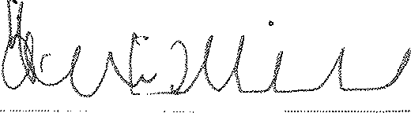
Heidi Viens, an individual

Dated: November . 201 5 National Federation of the Blind

By:

Name: Mark Riccobono Its: President

Dated: Novcmbcr, 201 5 Scribd, Inc.

Name: Tod Harmon
----=

Its: Vice President of Finance and Operations

10

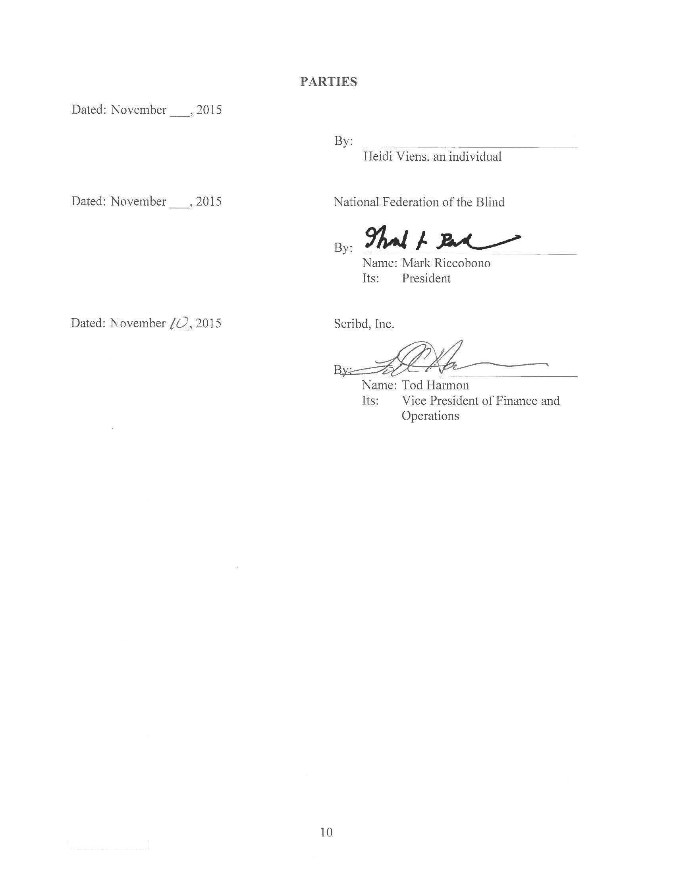

16

03665-0002 274439.1

